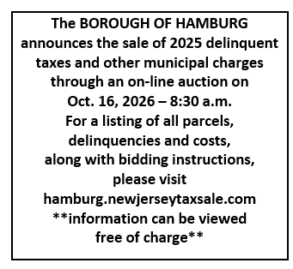
PUBLIC NOTICE
BOROUGH OF HAMBURG
NOTICE OF SALE OF REAL PROPERTY FOR NON-PAYMENT OF 2025 TAXES
AND OTHER MUNICIPAL CHARGES
PUBLIC NOTICE IS HEREBY GIVEN that I, Rebecca Westra, Collector of Taxes for the Borough of Hamburg, in the County of Sussex, State of New Jersey, shall sell at public auction, liens on the following described lands through an online Tax Sale at 8:30 a.m. on: WEDNESDAY, OCTOBER 16, 2026.
Bidders should submit their bids no later than 8:30 a.m., October 16, 2026 at hamburg.newjerseytaxsale.com
Liens shall be sold on the said lands and premises for the total amount of municipal liens, with interest and costs computed to the date of sale. The sale will be made and conducted in accordance with the provisions of the revised statutes of New Jersey of 1937 sec. 5:45-19, 54:5-11 et seq. as amended and supplemented.
Said land and premises to be sold are described in accordance with the last tax duplicate. Liens shall be sold on said lands, to such persons as will purchase the same, subject to redemption, at the lowest rate of interest, but not to exceed 18% per annum. Payment shall be made before the conclusion of the sale or the property will be resold. Only WIRE TRANSFERS will be accepted at the time of the sale. Properties for which there are no other purchasers will be struck off and sold to the Township of Hardyston at 18% percent per annum with the same remedies and rights as other purchasers, including the right to bar or foreclose the right of redemption.
Industrial properties may be subject to the Spill Compensation & Control Act (NJSA 58:10-23.11 et seq.), the Water Pollution Control Act (NJSA 58:10a-1 et seq.), and the Industrial Site Recover Act (NJSA 13:1k-6 et seq.). In addition, the municipality is precluded from issuing a tax sale certificate to any prospective purchaser who is or may be in any way connected to the prior owner or operator of the site.
The collector will receive payment of the amount due IN CASH, MONEY ORDER OR CERTIFIED CHECK only, on any property prior to 1:00 p.m. Thursday, October 15, 2026, with costs, all interest incurred (including any additional interest due on the current years delinquency) at the tax office in the municipal building.
In the event that the owner is on active duty in the military service, the tax collector should be notified immediately.
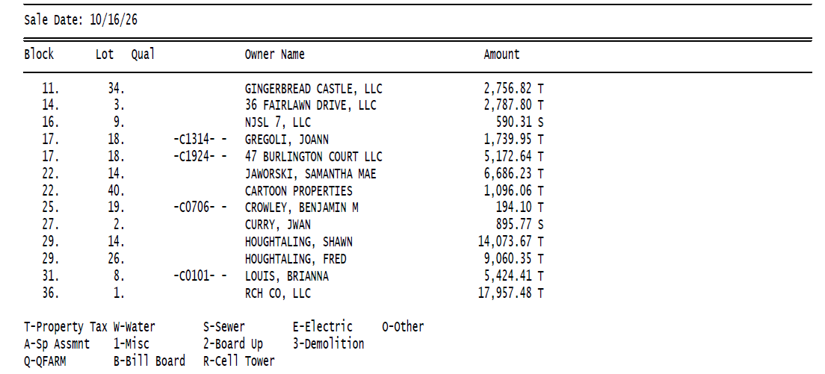
Rebecca Westra, C.T.C.

